**Practical No. 1:**

**Code:**

<!DOCTYPE html>

<html>

    <head>

        <title>Page Title</title>

    </head>

        <body>

            Web Page Designing using HTML

        </body>

</html>

**OUTPUT:**

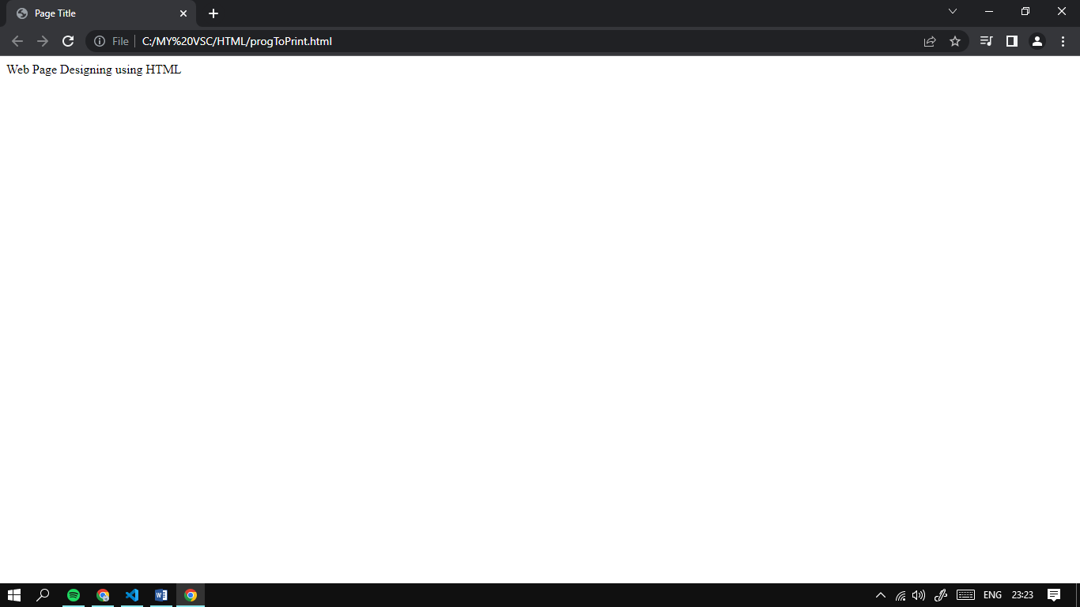

**Practical No. 2:**

**Code:**

<!DOCTYPE html>

<html>

    <head>

        <title>Block Level Tag</title>

    </head>

    <body>

        <body>

            <h1 align="center">This is h1 tag with center aligned</h1>

            <h2 align="left">This is h2 tag with left aligned</h2>

            <h3 align="right">This is h3 tag with right aligned</h3>

            <h4>This is h4 tag without alignment</h4>

            <h5>This is h5 tag without alignment</h5>

            <h6>This is h6 tag without alignment</h6>

            <br>

            <p>

                this is example of paragraph

            </p>

            this is a new sentence without a paragraph break

        </body>

    </body>

</html>

**OUTPUT:**

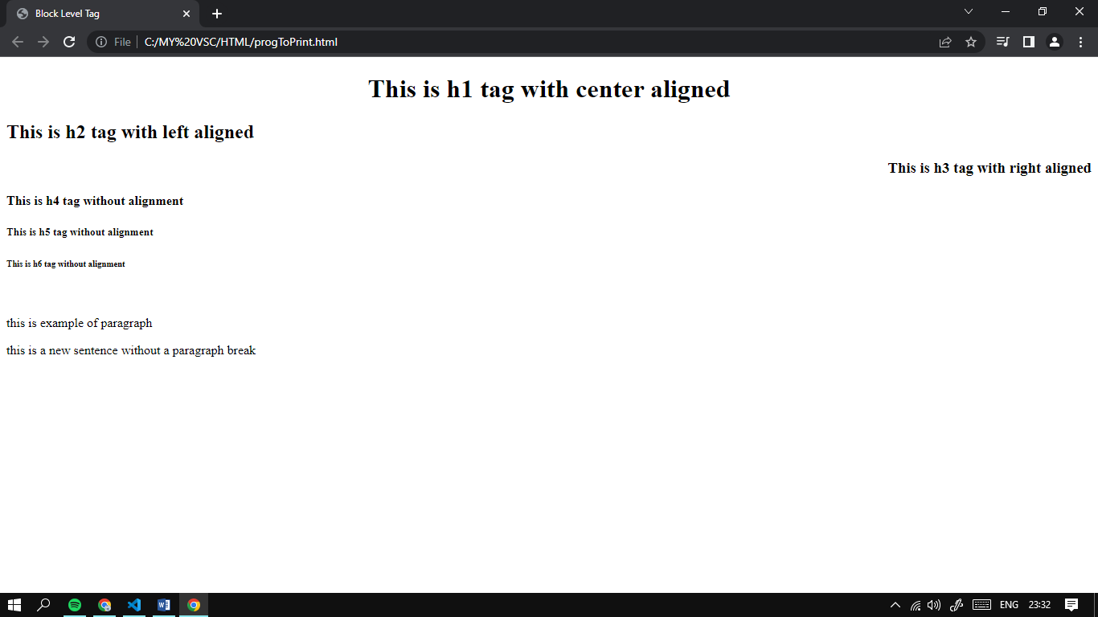

**Practical No. 3:**

**Code:**

<!DOCTYPE html>

<html>

    <head>

        <title>Block Level Tag</title>

    </head>

    <body>

        <body>

            <blockquote href="https://en.wikipedia.org/wiki/Wikipedia">

Wikipedia[note 3] is a multilingual free online encyclopedia written and maintained by a community of volunteers, known as Wikipedians, through open collaboration and using a wiki-based editing system called MediaWiki. Wikipedia is the largest and most-read reference work in history.[3] It is consistently one of the 10 most popular websites ranked by Similarweb and formerly Alexa; as of 2023, Wikipedia was ranked the 5th most popular site in the world.[4] It is hosted by the Wikimedia Foundation, an American non-profit organization funded mainly through donations.

            </blockquote><br>

            <pre>

                This pre formating tag is

                    used for indicating

                        performated text.

            </pre><br>

            <address>

                <a href="mailto:order@sample.com">

                    order@sample.com

                </a>

                <br>John Babbage

                <br>Box 212, Disneyland

                <br>Usa

                <br>

            </address><br>

            This horizontal rule tag represents a horizontal rule.

            <hr>

        </body>

    </body>

</html>

**OUTPUT:**

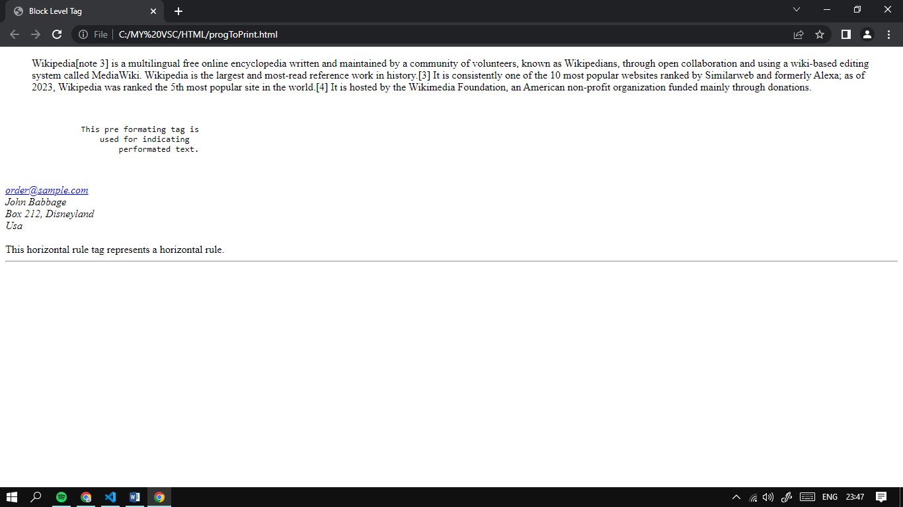

**Practical No. 4:**

**Code:**

<!DOCTYPE html>

<html>

    <head>

        <title>Text level tags and Special Char</title>

    </head>

    <body>

        <body>

            <p>

                One <sub>particular</sub> vook which is recommended

                reading in <u>The Street Lawyer</u> by <u>John Grisham</u>.

                <tt>This book is about a Lawyer who begins re-evaluating his

                priorities in life when a bad incidedent occurs whithin his

                lay firm.</tt>

            </p>

               <strike>Consequenntly, he becomes acquainted with the

                innet city streets, and realizes the harsh existence of the homeless</strike>.

                <u>The Street Lawyer</u> is a <b><i>great</i></b> book. It is

                <b><i>well written</i></b> and <b><i>intresting</i></b>.

                Other books by <sup><u>John Grisham</u></sup> include <u>The Firm</u> &amp;

                <u>The Pelican Brief</u> and <u>The Client</u>

        </body>

    </body>

</html>

**OUTPUT:**

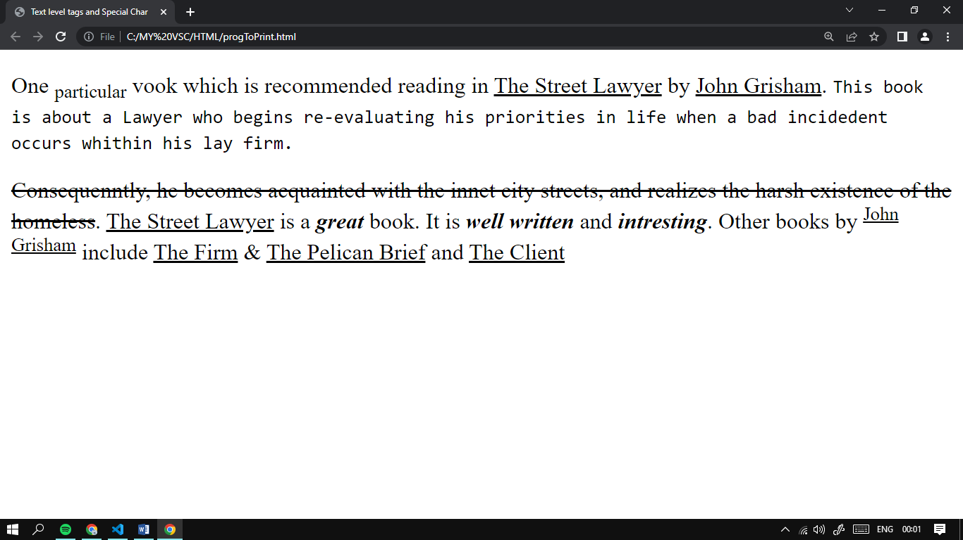

**Practical No.5:**

**Code:**

<!DOCTYPE html>

<html>

<head>

    <title>Practical 5</title>

</head>

<body>

    <h4>An Unordered List:</h4>

    <ul>

        <li>Beetroot</li>

        <li>Ginger</li>

        <li>Potato</li>

        <li>Radish</li>

    </ul>

    <br>

    <h4>An Ordered Nested List:</h4>

    <ol>

           <li>Coffee</li>

            <li>Tea

                <ol type="a">

                    <li>Green Tea</li>

                    <li>Black Tea

                        <ol type="i">

                            <li>China</li>

                            <li>Africa</li>

                        </ol>

                    </li>

                </ol>

            </li>

            <li>Milk</li>

        </ol>

    <br>

    <h4>HTML Defination List:"</h4>

    <p>

        <dl>

            <dt>HTML</dt>

            <dd>This stands for Hyper Text Markup Language</dd>

            <dt>HTTP</dt>

            <dd>This stands for Hyper Text Trasfer Protocol</dd>

          </dl>

    </p>

</body>

</html>

**Output:**

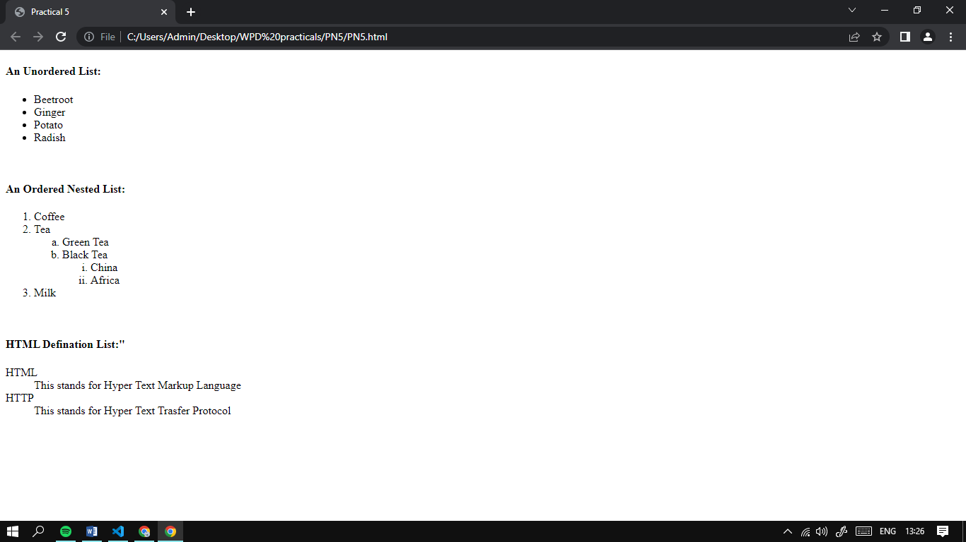

**Practical No. 6:**

**Code 1:**

<!DOCTYPE html>

<html>

<head>

    <title>Homepage for KVMIT</title>

</head>

<body>

    <h2>KVMIT</h2>

    <p><a href="CO.html">Computer Operations</a></p>

    <p><a href="IF.html">Information Technology</a></p>

</body>

</html>

**Code 2:**

<!DOCTYPE html>

<html>

<head>

    <title>Computer Coperations</title>

</head>

<body>

    <p>This is the Webpage for CO branch</p>

    <p><a href="Homepage.html">Back to Homepage</a></p>

</body>

</html>

**Code 3:**

<!DOCTYPE html>

<html>

<head>

    <title>Information Technology</title>

</head>

<body>

    <p>This is the Webpage for IF branch</p>

    <p><a href="Homepage.html">Back to Homepage</a></p>

</body>

</html>

**Output:**

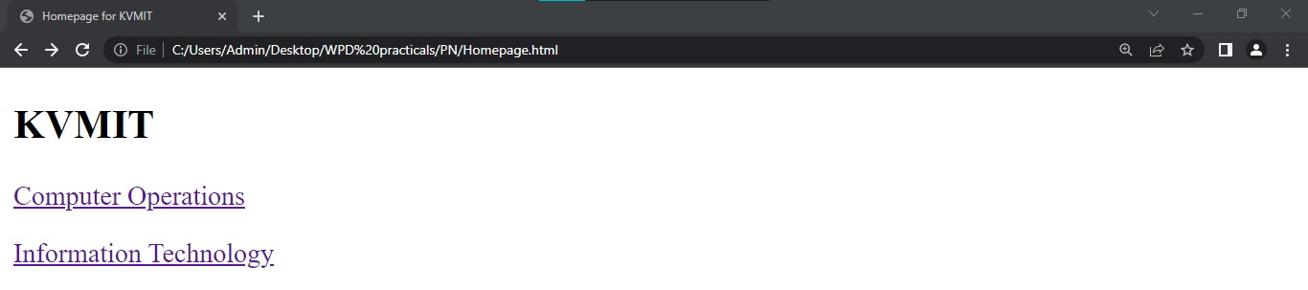

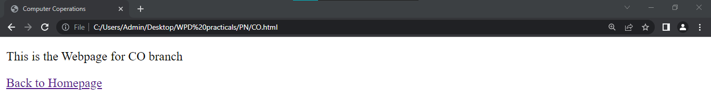

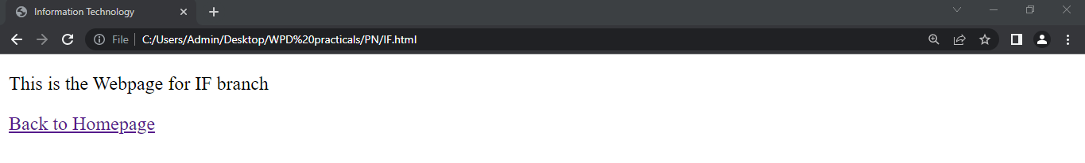

**Practical No. 7:**

**Code:**

<!DOCTYPE html>

<html>

<head>

    <title>Practical 7</title>

    <style>

        a:link{color: green;}

        a:visited{color: pink;}

        a:hover{color: red;}

        a:active{color: yellow;}

    </style>

</head>

<body>

    <p><a href="https://www.google.com/">Got to Google</a></p>

    <p><a href="mailto:myemail@gmail.com">Email Us</a></p>

</body>

</html>

**Output:**

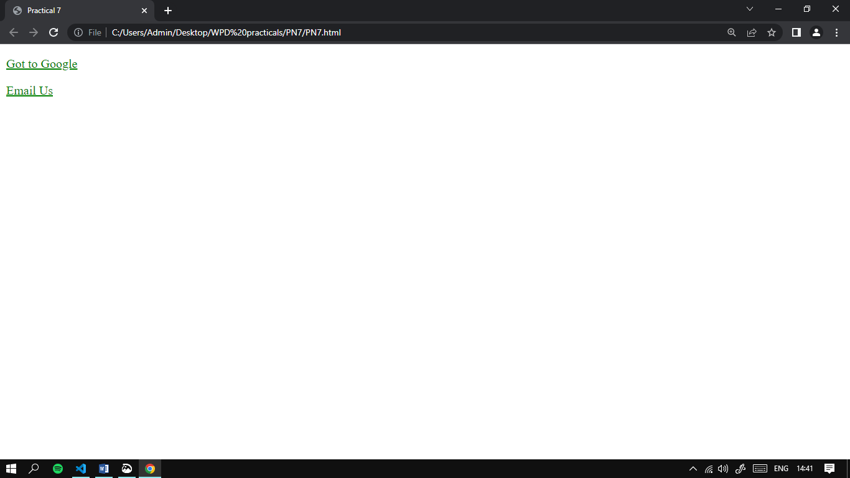

**Practical No. 8:**

**Code:**

<!DOCTYPE html>

<html>

<head>

    <title>Practical 8</title>

</head>

<body>

    <img src="senary.jpg" height="260" width="400" border="10" hspace="75" vspace="75"/>

</body>

</html>

**Output:**

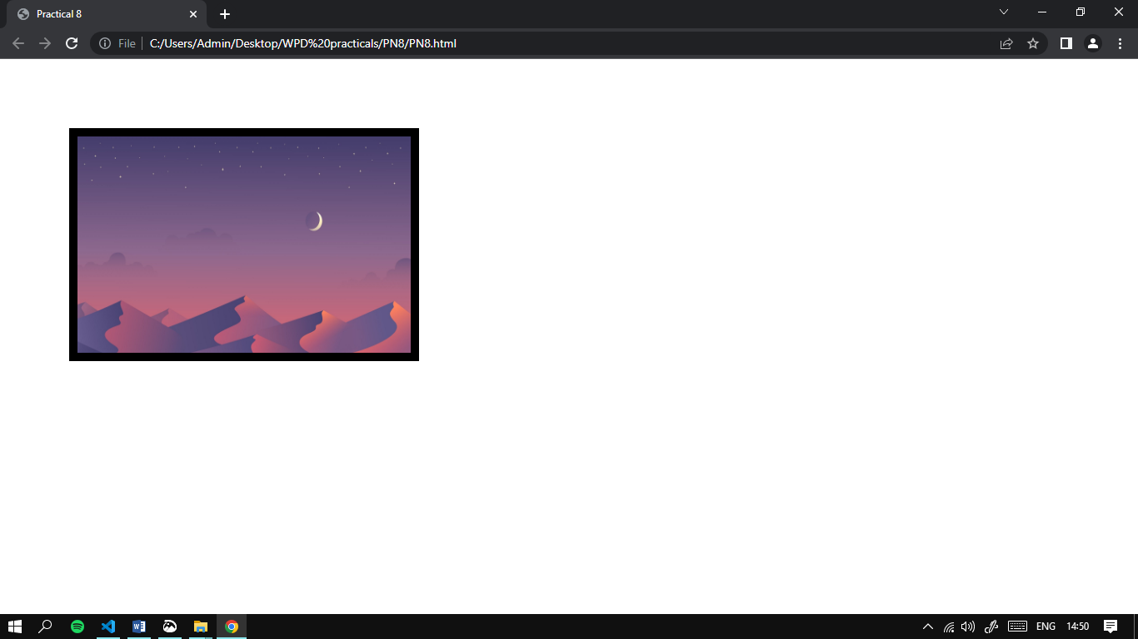

**Practical 9:**

**Code 1:**

<!DOCTYPE html>

<html>

<head>

    <title>Practical 9</title>

</head>

<body>

    <h3 align="center">Image as Hyperlink:</h3>

    <a href="PN9_2.html">

        <img src="button.png" border="10" height="150" width="250" hspace="100"/>

    </a>

</body>

</html>

**Code 2:**

<!DOCTYPE html>

<html>

<head>

    <title>Practical 9</title>

</head>

<body background="background.jpg">

    <h2 align="center">This Page Has A Background</h2>

</body>

</html>

**Output:**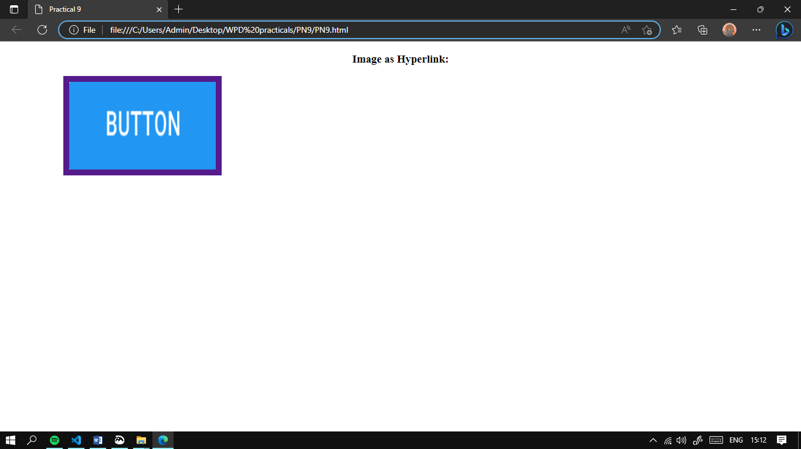

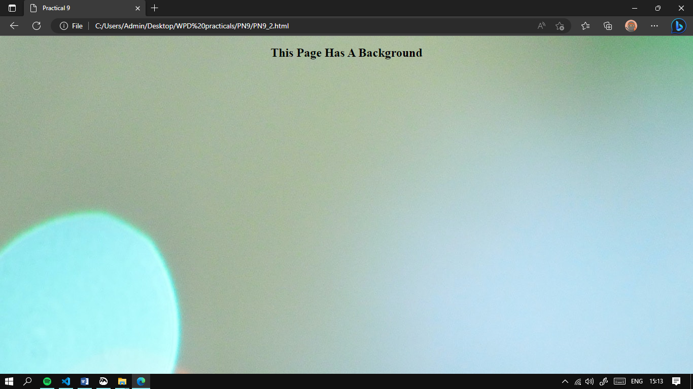

**Practical No. 10:**

**Code 1:**

<!DOCTYPE html>

<html >

<head>

    <frameset rows="*,*">

        <frame src="PN10_2.html"></frame>

        <frame src="PN10_3.html"></frame>

    </frameset>

    <title>Practical 10</title>

</head>

<body>

</body>

</html>

**Code of PN10_2.html:**

<!DOCTYPE html>

<html >

<head>

    <title>Practical 10</title>

</head>

<body>

    <h2 align="center">Row 1</h2>

</body>

</html>

**Code of PN10_3.html:**

<!DOCTYPE html>

<html >

<head>

    <frameset cols="*,*,*">

        <frame src="PN10_4.html"></frame>

        <frame src="PN10_5.html"></frame>

        <frame src="PN10_6.html"></frame>

    </frameset>

    <title>Practical 10</title>

</head>

<body>

</body>

</html>

**Code of PN10_4.html:**

<!DOCTYPE html>

<html >

<head>

    <title>Practical 10</title>

</head>

<body>

    <a href="#">Text Link 1</a>

    <a href="#">Text Link 2</a>

    <a href="#">Text Link 3</a>

</body>

</html>

**Code of PN10_5.html:**

<!DOCTYPE html>

<html >

<head>

    <title>Practical 10</title>

</head>

<body>

    <ol>

        <li>Item 1</li>

        <li>Item 2</li>

        <li>Item 3</li>

        <li>Item 4</li>

    </ol>

</body>

</html>

**Code of PN10_6.html:**

<!DOCTYPE html>

<html >

<head>

    <title>Practical 10</title>

</head>

<body>

    <img src="KVMIT.jpg" width="300" height="200" border="10"/>

</body>

</html>

**Output:**

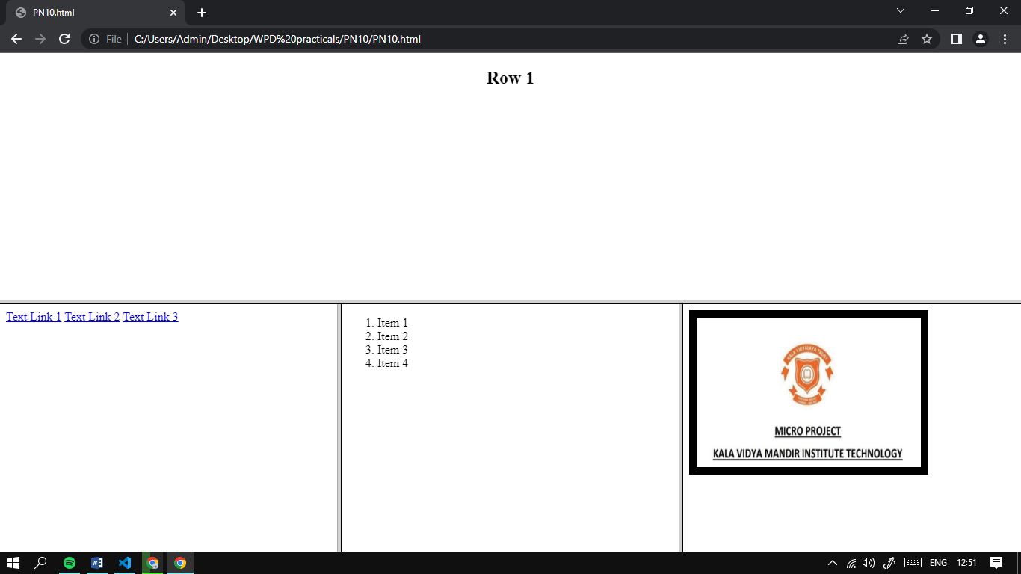

**Practical No. 11:**

**Code:**

<!DOCTYPE html>

<html>

<head>

    <title>Practical 11</title>

</head>

<body>

    <p>

        <h3 align="center">Table with border, vertical headers, cellpadding and cellspacing</h3>

        <table align="center" border="5" align="center" cellpadding="10" cellspacing="5">

            <tr>

                <th>Day/Time</th>

                <th>10:00-12:00</th>

                <th>12:00-1:00</th>

                <th>1:00-2:00</th>

                <th>2:00-4:00</th>

            </tr>

            <tr>

                <th>Monday</th>

                <td>MATHS</td>

                <td>PIC</td>

                <td rowspan="5">RECESS</td>

                <td>CHEM</td>

            </tr>

            <tr>

                <th>Tuesday</th>

                <td>PHY</td>

                <td>ENG</td>

                <td>WPD</td>

            </tr>

            <tr>

                <th>Wednesday</th>

                <td>PIC</td>

                <td>CHEM</td>

                <td>MATHS</td>

            </tr>

            <tr>

                <th>Thusday</th>

                <td>PHY</td>

                <td>ENG</td>

                <td>WPD</td>

            </tr>

            <tr>

                <th>Friday</th>

                <td>WPD</td>

                <td>MATHS</td>

                <td>CHEM</td>

            </tr>

        </table>

    </p>

</body>

</html>

**Output:**

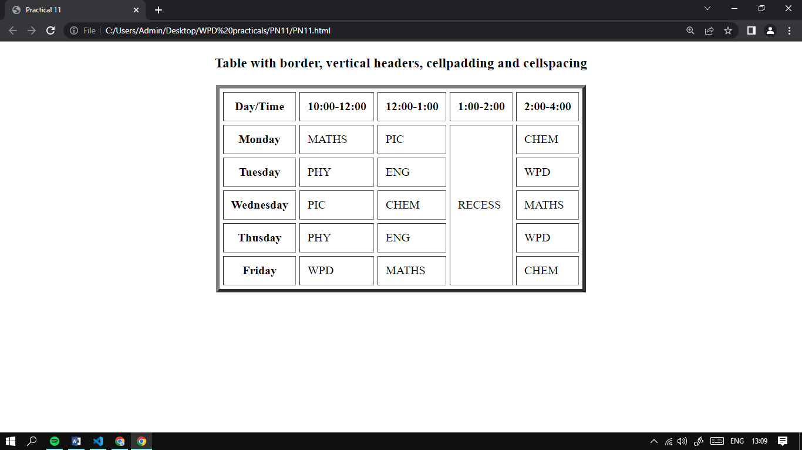

**Practical No. 12:**

**HTML Code:**

<!DOCTYPE html>

<html>

<head>

    <link rel="stylesheet" href="style.css">

    <title>Practical 12</title>

</head>

<body>

    <div class="container">

        <div class="menu">

            <h1>My First<br>Website</h1>

            <ul>

            <li></a><button><a href="#" class="JoinUs-btn">Home</a></button></li>

            <li><button><a href="#" class="JoinUs-btn">About</a></button></li>

            <li><button><a href="#" class="JoinUs-btn">Staff</a></button></li>

            </ul>

        </div>

        <div class="app-text">

                <p>

                    HOME<br><br>

                    This is my first webpage! I was able to code all the HTML<br> and CSS in order to make it.

                    Watch out world of web design here I come!

                </p>

        </div>

    </div>

</body>

</html>

**CSS Code:**

*{

    margin: 0;

    padding: 0;

}

.container{

    width: 100%;

    height: 100%;

    background-color: antiquewhite;

    height: 200vh;

    width: 100%;

}

.menu ul{

    text-decoration: none;

    display: inline-flex;

    margin: 50px;

    float: right;

}

.menu ul li{

    list-style: none;

    margin: 0 20px;

    cursor: pointer;

}

.menu h1{

    float: left;

    font-size: 60px;

    padding: 18px;

    padding-left: 50px;

    padding-right: 50px;

}

.JoinUs-btn {

    top: 50px;

    right: 80px;

    font-size: 20px;

    text-align: center;

    text-decoration: none;

    background-color: burlywood;

    color: black;

    padding: 40px 40px; /* increased left and right padding */

    display: block;

  }

.app-text{

    width: 100%;

    float: left;

}

.app-text p {

    align: center;

    width: 90%;

    padding: 20px;

    font-size: 30px;

    margin: 40px 0 30px 50px;

    background-color: white;

    border-radius: 15px;

    border: 2px solid black;

}

**Output:**

